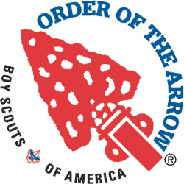
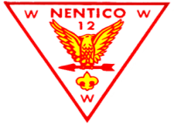
Harford Chapter – Order of the Arrow
Arrow of Light / Cross-Over (Bridging) - Ceremony - Request Form
Unit Number: ______________ Date Requested: ________________ Time: __________________
Location: _________________________________________________________________________________
__________________________________________________________________________________
__________________________________________________________________________________
Contact Information: Name/s: ________________________________________________________________
Home Phone #:________________________ Cell Phone #:_____________________________
E Mail Address: ________________________________________________________________

Is this for (Circle One): Arrow Of Light Ceremony only Cross Over Ceremony only Both

We DO NOT do a graduation ceremony for every rank advancement (Tiger, Bob Cat, Wolf, Bear, etc.).
This is only for receiving the Arrow Of Light and can include the Cross Over to a Troop.

What is this event (Circle One): Pack Meeting Blue & Gold Banquet Court of Honor Other – Explain: ______________________________________________
Important notes:

We are not permitted to shoot Flaming Arrows.

Twice during the ceremony the ceremonialists will present “tokens” to the youth. These tokens are to be provided by the Pack. The first is usually a ceremonial arrow. Often it is mounted on a board. Most Packs make these for the AOL recipients. If you do not have them, you can substitute something else such as the AOL patch, pin, certificate, etc. The second is usually the patch or pin. If the pack does not have anything for the second token, the ceremonialists will shake their hand. The tokens do not have to be anything expensive.

If they are Crossing Over (Bridging) to a Troop, will representatives of that Troop/s be there to greet them after they cross the bridge?
Do you have or can you improvise a bridge for them to cross?
We will need the name/s of those receiving the Arrow of Light.
We will need the name/s of those that are Crossing Over (Bridging) to a Troop.
We will need the Troop number/s to which those Crossing Over (Bridging) are joining.

Please send this completed form to:
Nolan Phillips –Harford Chapter Ceremony Committee - Adviser – Nentico Lodge Order of the Arrow
E Mail: Nolan.Phillips@Evonik.com (Best Way to Communicate)
Home Address: 512 East Craighill Channel Drive, Perryville, Maryland 21903
Work Phone: 410-939-7222 (Best Way to Call) Home Phone: 410-642-0160

